**MODULE 4**

1. **What are the main factors that can affect PPC bidding?**

ANSWER 1

There are some important factors of PPC bidding . Quality score, Keyword bid, AD Position, Cost to Company .

1. **How does a search engine calculate actual CPC?**

ANSWER 2

CPC is calculated by dividing the total cost of your clicks by the total number of clicks. Your average CPC is based on your actual cost-per-click(actual CPC), which is the actual amount you are charged for a click on your ad.

1. **What is a quality score and why it is important for Ads?**

ANSWER 3

Quality Score is Google’s rating of the quality and relevance of your keywords, landing pages, and PPC campaigns. Advertisers with better Quality Scores get more ad clicks at lower costs.

1. **Create an ad for your website/ blog in Google Ads that display on the display network with the properly targeted audience**

ANSWER 4

We create Google ad and we share screenshot to my Google Ads …

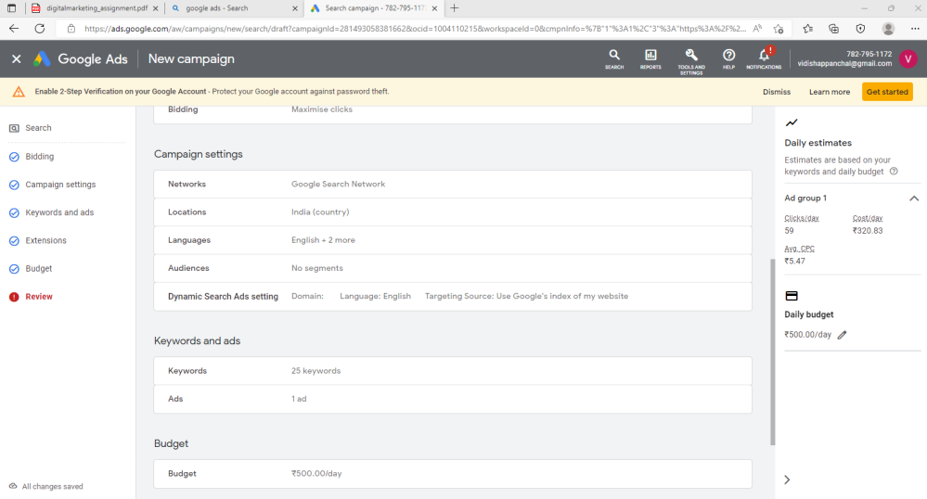

1. **Create an ad for** [**https://vidisha111.blogspot.com/2022/06/always-think-positive.html**](https://vidisha111.blogspot.com/2022/06/always-think-positive.html) **to get the maximum Clicks.**

ANSWER 5.

We create Google ad and we share screenshot to my Google Ads …

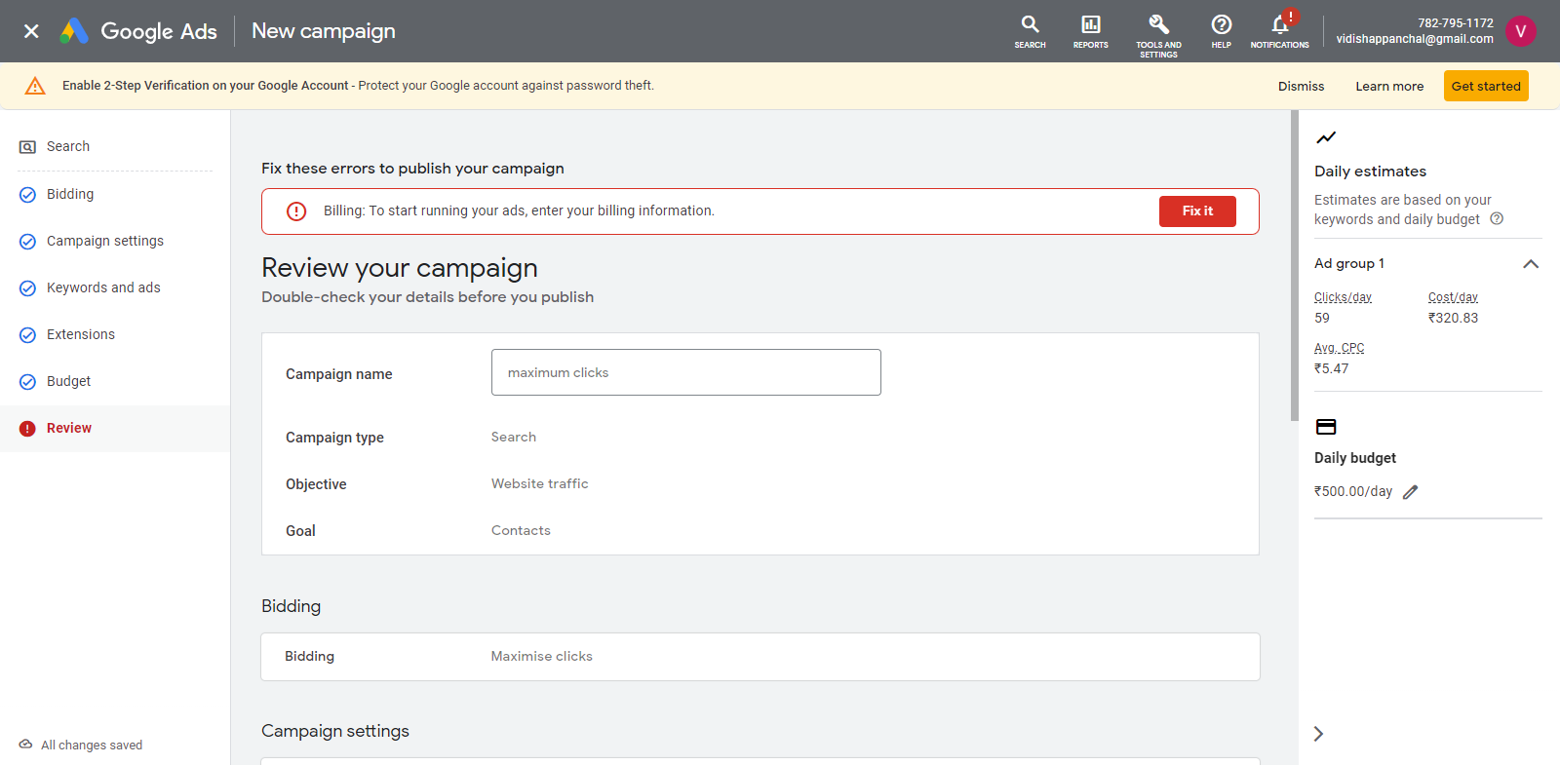

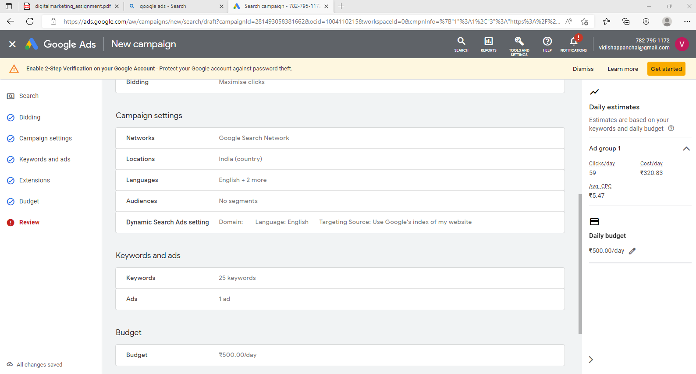

1. **Create an ad for** [**https://vidisha111.blogspot.com/2022/06/always-think-positive.html**](https://vidisha111.blogspot.com/2022/06/always-think-positive.html)

**-o Create an ad for the display network.**

**-o Choose a proper Target audience.**

**-o Expected conversion: need maximum user engagement within the budget.**

**-o Budget: 5000.**

ANSWER 6.

We can create ad and we can display screenshot to display network, target audience

and Budget to 5000 Rs. .

